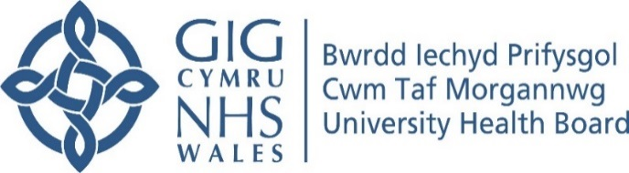
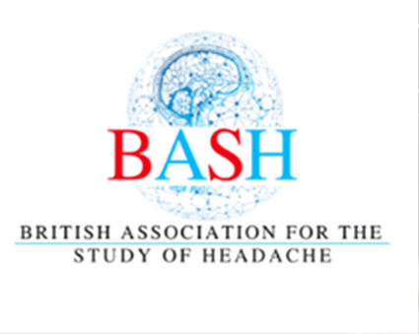
EDUCATIONAL CONFERENCE ON HEADACHE
Cardiff Marriott Hotel
Mill Lane, Cardiff, CF10 1EZ
Friday 18th October 2024
9.00 – 5.00pm

8.30–9.00 | Registration and Coffee
9.00–9.15 | Warm welcome by Chair, Dr Mohamed Hassan, Consultant Acute Physician
Morning Session:

9.15–9.45 | Update on Migraine  Pathophysiology | Dr Philip Holland  Neuroscientist
9.45–10.15 | Update on Anti-CGRP | Professor Fayyaz Ahmed  Neurologist/Headache specialist
10.15–10.45 | Post Traumatic Headache (PTH) | Dr Krishna Dani Neurologist/Headache specialist
10.45–11.00 | Coffee Break
11.00–11.30  11.30-11.50 | SIH  Diagnosis and Treatment  Difficult facial pain/Headache  (In GP Surgery) | Professor Manjit Matharu, Neurologist/Headache Specialist  Dr Paul Ballinger  GP/Headache Specialist
11.50–12.10 | Empowering Patients  Signposting to resources | Dr Katy Munro  GP/Headache specialist
12.10–12.40 | How to survive the ten minutes  headache consultation | Dr David Kernick  GP/Headache Specialist, Exeter
12.40–1.00 | Headache in pregnancy | Dr Benjamin Wakerley  Neurologist/ Headache Specialist
1.00–2.00 | Lunch

Afternoon Session:

Headache and Facial Pain

2.00–2.30 | Trigeminal Neuralgia  Update on Diagnosis and Treatment | Prof Joanna Zakrzewska,  Consultant Facial Pain
2.30–3.00 | Temporal arteritis | Dr Emyr Humphreys  Consultant Rheumatologist
3.00–3.30 | Persistent Idiopathic Facial Pain | Professor Tara Renton  Oral Surgery
3.30–3.45 | Coffee Break

Headache at Front Door Dr ROBIN CORKILL
Consultant Neurologist
&
Dr MOHAMED HASSAN
Consultant acute physician

3.45–4.00 | Thunderclap Headache | PCH/UHW  *************
4.00-4.20 | Headache and Orbital Swelling X2 CASES | PCH/UHW  *************
4.20–4.40 | Headache and Stroke in a young lady | PCH/UHW  *************
4.50-5.00 | Q&A
 | Close

This course has been approved and granted 6 external CPD credits

